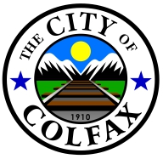

City of Colfax

Represented Employees (Non-Rep Emp Sheet Available)

City pays 100% of first $800 of cost and 90% of cost over $800 to a max of $1840 – with the employee paying 10% of the cost and any amount over City maximum.