NOTICE OF PREPARATION AND
NOTICE OF PUBLIC SCOPING MEETING

Date: | July 7, 2023

To: | State Clearinghouse  State Responsible Agencies  State Trustee Agencies  Other Public Agencies  Interested Organizations | From: | Emmanuel Ursu, Planning Director  City of Colfax  Planning Department  33 S Main Street  Colfax, CA 95713

Subject: | Notice of Preparation (NOP) for the City of Colfax General Plan Update Environmental Impact Report (EIR) and Notice of Public Scoping Meeting
Lead Agency: | City of Colfax
Project Title: | City of Colfax General Plan 2040 Update
Project Area: | City of Colfax and Sphere of Influence
Project Location: | The City of Colfax is the eastern-most incorporated city in Placer County, located in the Sierra Nevada Foothills. Colfax is bordered by unincorporated Placer County lands. The city covers an area of 1.3 square miles and is bisected by Interstate 80 (I-80). Colfax is situated a few miles outside the Tahoe National Forest as I-80 begins its climb into the Sierra Nevada mountains. The City of Colfax is in the western part of Placer County, approximately 46 miles northeast of Sacramento and 68 miles southwest of Reno. Interstate and regional access to Colfax is provided by I-80 and Union Pacific Railroad which runs in a general north-south direction and bisects the city. Rail freight access is provided by the Union Pacific Railroad; Amtrak provides daily passenger service north and south of Colfax. Figure 1, Regional Location, shows the General Plan area in its regional context.
Scoping Meeting: | 11 AM, Thursday, July 20, 2023

PURPOSE
In accordance with Section 15021 of the California Environmental Quality Act (CEQA) Guidelines, the City of Colfax, as lead agency, will prepare an Environmental Impact Report (EIR) for the Colfax General Plan Update 2040. (General Plan Update). Pursuant to Section 15082(a) of the CEQA Guidelines, the City of Colfax (City) has issued this Notice of Preparation (NOP) to provide responsible agencies, trustee agencies, and other interested parties with information describing the General Plan Update and its potential environmental effects. The City is soliciting your comments on the scope of the environmental analysis.

REVIEW PERIOD
Section 15082(b) of the CEQA Guidelines requires comments to be provided within 30 days of receipt of a NOP. In compliance with the time limits mandated by CEQA, the comment period for this NOP is from Friday July 7, 2023, through Monday, August 7, 2023. Please email your written comments to Emmanuel Ursu at planning@colfax-ca.gov, or physically mail them to City Hall, P.O. Box 702, 33 South Main St Colfax, CA 95713. Please include the name, email and/or telephone number of a contact person at your agency or organization who can answer questions about the comment.
SCOPING MEETING
The City will hold a Public Scoping Meeting at 11 AM on Thursday, July 20, 2023 for the EIR to describe the proposed project, the environmental review process, and to receive your verbal input on the information that should be included in the EIR.

PROJECT DESCRIPTION
The General Plan establishes the community’s long-term vision for the future, including where people in Colfax will live, work, shop, and recreate. It serves as guidance for all zoning and land use decisions within the city. It will shape future housing, support job growth, foster healthy and resilient neighborhoods, protect and manage natural resources, ensure community safety, and promote social and economic equity. This General Plan Update does not make major changes in land use, but is focused on shortening the existing document, consolidating goals and policies into a more user-friendly document, and recognizing the need for different styles of development than were prevalent with the existing General Plan, adopted in 1998.
The General Plan policy document contains the goals and policies that will guide future decisions within the city and identifies implementation measures to ensure the vision and goals of the General Plan are carried out. The General Plan also contains a land use diagram, which serves as a general guide to the distribution of land uses throughout the city. The General Plan addresses all the elements required by State law, in addition to optional elements that the City has elected to include, as shown below:

- Land Use Element

- Community Design Element (Optional Element)
- Circulation Element
- Housing Element (Stand-alone Element)
- Noise Element
- Safety Element
- Conservation and Open Space Element
- Economic Development Element (Optional Element)

The General Plan land area consists of 903 acres (1.4 square miles) within the city limits, and 2,056.3 acres (3.2 square miles) within the Sphere of Influence. The total land area covered by this General Plan is 2,959.3 acres (4.6 square miles). Figure 2, Proposed Land Use Plan Diagram illustrates the proposed 2040 General Plan land use diagram.
Additional information regarding the General Plan Update can be found on the City’s website:
https://colfax-ca.gov/government/planning/colfax-planning-documents/.

ENVIRONMENTAL IMPACT REPORT
As all of the CEQA topics will be included in the EIR, the City has not prepared an Initial Study for this NOP as permitted in Section 15060(d) of the CEQA Guidelines. In accordance with §15166 of the CEQA Guidelines, the EIR will be included as a chapter in the General Plan as it satisfies the following requirements:
- The general plan addresses all the points required to be in an EIR by Article 9 of these guidelines and
- The document contains a special section or a cover sheet identifying where the general plan document addresses each of the points required.
Probable Environmental Effects/EIR Scope: The EIR for the proposed project will address the range of impacts that could result from adoption and implementation of the General Plan Update. Below is a list of environmental topics that will be examined in the EIR.

- Aesthetics
- Land Use and Planning
- Agricultural and Forestry Resources
- Mineral Resources
- Air Quality
- Noise
- Biological Resources
- Population and Housing
- Cultural Resource
- Public Services
- Energy
- Parks and Recreation
- Geology and Soils
- Transportation
- Greenhouse Gas Emissions
- Tribal Cultural Resources
- Hazards and Hazardous Materials
- Utilities and Service Systems
- Hydrology and Water Quality
- Wildfire

Attachments:
Figure 1: Regional Location
Figure 2: Proposed Land Use Plan Diagram

Figure 1: Regional Location
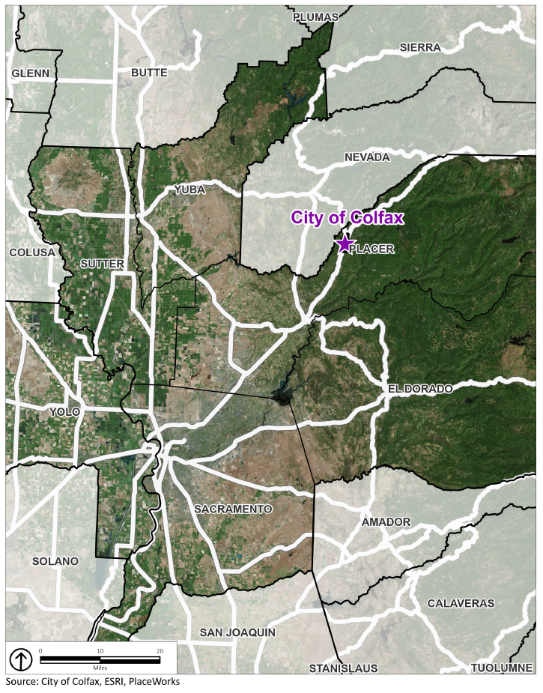

Figure 2: Proposed Land Use Plan Diagram


