GUIDELINES FOR ORDINANCE NO. 499
ORDINANCE REQUIRING TESTING, INSPECTION, REPAIR AND
REPLACEMENT OF BUILDING SEWER LATERALS

FAQ’s for the Property Owner
Q: Who is responsible for sanitary sewer repair?
A: The City of Colfax maintains all public sanitary sewer mains. This includes over 10 miles of pipelines which are generally located within public streets or easements dedicated for City use.
Each home or commercial building has a separate connection to the public sanitary sewer main called a building sewer lateral. In accordance with City Ordinance No. 499, it is the property owner's responsibility to maintain and repair their own building sewer lateral from the house up to the point of connection with the public sanitary sewer main. This includes both the portion on private property and the portion located beneath the sidewalk and street up to the point where the lateral connects to the public main. The drawing below illustrates the difference between a sewer lateral and a public sanitary sewer main.
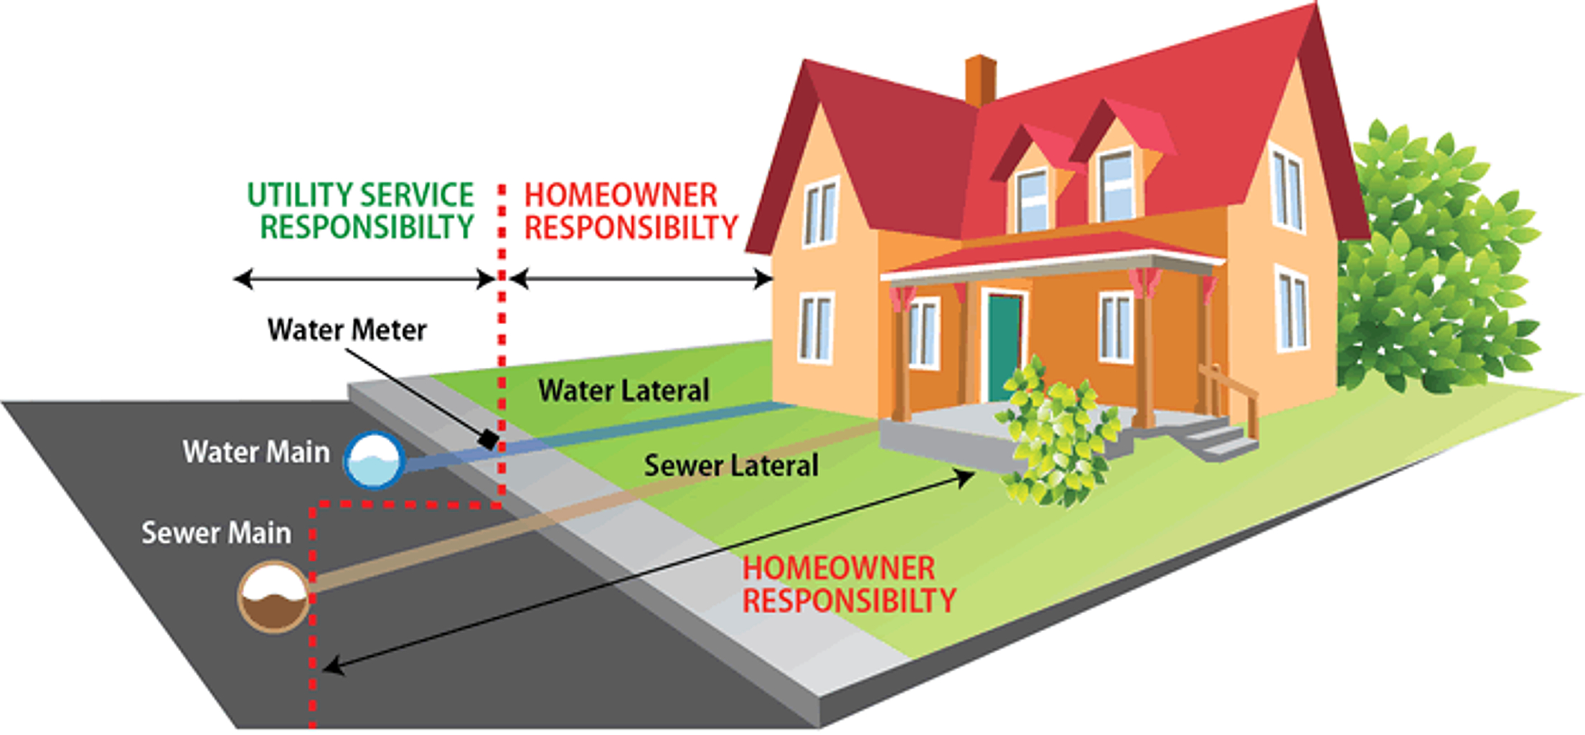
Q: Why is the City concerned about the condition of the sewer lateral?
A: Sewer laterals which are in poor condition present two problems: (1) faulty sewer lines can leak raw sewage in the ground, which may be a public health issue; (2) storm water can invade poorly sealed sewer lines and can overload the sewer system, causing sanitary sewer overflows (880s) and backups, and can occasionally overload the wastewater treatment facilities, resulting in the discharge of partially treated wastewater.
Q: At what point(s) am I required to clean, test, repair or replace my sewer lateral?
A: You may voluntarily choose to repair or replace your sewer lateral at any time you feel it is necessary (for example, if you are experiencing frequent sewer backups or blockages). However, the City Municipal Code now requires that sewer laterals be cleaned and tested, and repaired or replaced as necessary and receive a Certificate of Compliance from the City under any of the following conditions:
(A) The installation of additional plumbing facilities that produce a major, increase, in the judgment of the City of Colfax, in sewage flow from the house, building, property or other structure served.
(B) Whenever property located in the City of Colfax is remodeled or modified with an estimated or actual remodel or modification cost or value in excess of $20,000 as determined by the City.
(C) A change of use of the house, building, property or other structure served from residential to business, commercial, or other non-residential, or from non-residential/non-restaurant/non-industrial to restaurant or industrial uses such as carwashes, cleaners and laundries.
(D) Upon repair or replacement of any portion of the Building Sewer Lateral.
(E) Upon a determination by the City of Colfax that the cleaning, testing, repair or replacement is required for the protection of the public health, safety and welfare.
(F) Prior to the close of escrow upon a sale or other transfer of the house, building, property or other structure served or, if there is no escrow, prior to recording a deed or other document transferring title to the house, building, property or other structure served.
(G) In a probate or other testamentary proceeding or in the event of a transfer pursuant to the terms of a revocable living trust, joint tenancy termination or other similar instrument, within 180 days after the sale, transfer or conveyance of the house, building, property or other structure connected to the City's Public Sewer Main.

Q: What are the problems associated with sewer laterals?

A: Most homes in the City were built before 1950, and often have never replaced their original sewer laterals. Over time, these pipelines, can crack, become disjointed, experience displacement, and/or be subjected to intrusion by roots, all of which can cause leakage and blockage. In addition, some sewer laterals lack proper "cleanouts," which provides access for clearing blockages.
Q: How do I find out where the problem is?
A: When a sewer backup or other problem occurs, in most cases it will not be obvious whether the problem area is in the sewer lateral or the public main. If this occurs, call the City at (530) 346-2313.
The City will come out to inspect the public sewer main free of charge. If a problem is found within the public main, it will be repaired as soon as possible. If the public main is found to be clear, the property owner will be informed that the blockage is probably in the sewer lateral. In this case, the property owner is responsible for maintenance or repair.
Caution: When trying to locate a sewer problem, never open manholes or other City structures. Due to potential hazards, only City personnel are authorized to open and inspect these structures.

Q: How do I proceed with a sewer lateral problem?
A: If the sewer problem is found to be in the sewer lateral, the property owner can hire a contractor to make repairs or, if equipped, can make repairs themselves. Contractors are listed in the yellow pages of the phone book under "Plumbing Drain & Sewer Cleaning" or "Sewer Contractors".
Before any work begins, a City Application for City Sewer Lateral Testing Permit package is required (even for repairs on private property). The City Sewer Lateral Testing Permit package will include documents that set forth the minimum standards for inspection, videotaping, repair and replacement of sewer laterals, for the purpose of obtaining a Sewer Lateral Certificate of Compliance. More information on how to obtain the Permit package is available by calling: (530) 346-2313. .
Q: How can I avoid damage to other utilities?
A: When digging to make sewer repairs, it is very important to know where other utilities are located so that damage can be avoided. Most utility companies belong to a locating service called Underground Service Alert (USA). By calling USA at 1-800-227-2600, the utility companies will be notified that you are planning to dig and will come out, free of charge, to mark the location of their utility lines.

Q: What permits are required for repairs in a street?

A: If a sewer lateral repair involves digging in a street or other public right-of-way, in addition to the City Application for City Sewer Lateral Testing Permit package, an encroachment permit will also be required. Encroachment permits are available from the City. To obtain a City Encroachment Permit for repairs outside of the property line, call: (530) 346-2313

Q: Where do I find a contractor to repair or replace my sewer lateral?
A: The City has a list of plumbing contractors that are registered with the City. If you wish to check a contractor's license, you may do so with the State's Contractors License Board, using their toll free number or Web site. Most of these contractors are also able to make sewer videos.

Q: How do obtain a Certificate of Compliance?
A: As a condition of obtaining a Certificate of Compliance, as a minimum, the Property Owner must submit an Application for a Certificate of Compliance along with the Sewer Lateral Close Circuit Television (CCTV) Inspection Report and CCTV Videotape demonstrating that the sewer lateral is in compliance with City Ordinance. Upon review of the Inspection Report and CCTV Videotape, if determined by the City that the Building Sewer Lateral(s) passes the testing procedure, required by City Ordinance 499, and upon payment of the fees required by the City, the City Engineer, or his or her designee, shall issue a signed Certificate of Compliance to the Property Owner.

Q: Do I need to obtain a Certificate if my home is under 10 years old?

A: All homes are subject to the Sewer Lateral Ordinance. A home that is newer than 10 years will likely have proof of a Sewer Lateral inspection on the building permit. If you can provide proof that the Sewer Lateral was tested, inspected and approved, then a new Certificate will not be necessary prior to the close of escrow or other transfer of the building.
Q: What if the House was sold within the last 10 years?
A: Call City Hall: 436-2313 and ask if there is a Valid Sewer Lateral Certificate on file. If the Certificate is on file, then it is not necessary to obtain a permit for an inspection.

